**23CSE111**

**LAB MANUAL**



**Department of CSE**

**Amrita School of Engineering**

**Amrita Vishwa Vidyapeetham, Amaravati Campus**

**Verified By :- Name: M.ARCHITH**

**Roll No: AV.SC.U4CSE24223**

|  |  |  |  |  |
| --- | --- | --- | --- | --- |
| S.NO | Programs | Date | Pg:No | Signature |
| 1 | 1. Download and Install Java Software. 2. Write a java program to print message “Welcome to java programming”. 3. Write a java program that prints name,roll number,section of a student. |  |  |  |
| 2 |  |  |  |  |
| 3 |  |  |  |  |
| 4 |  |  |  |  |
|  |  |  |  |  |
|  |  |  |  |  |
|  |  |  |  |  |
|  |  |  |  |  |

Week-1

# Program-1:-

## Aim:-Download and Instal the Java Software Procedure Step-1:- Type Java download in search

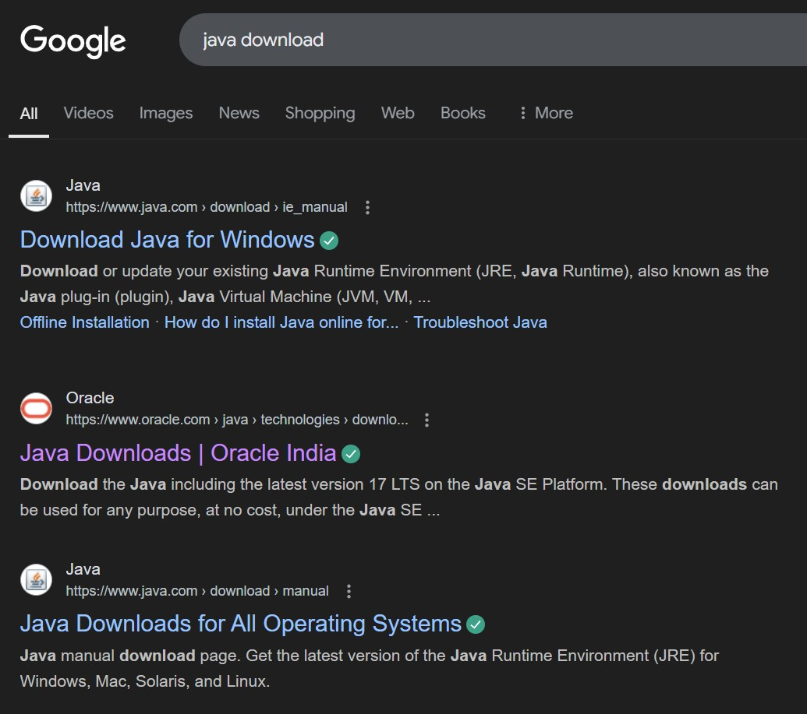

## Step-2:-click on oracle java download and enter into oracle website

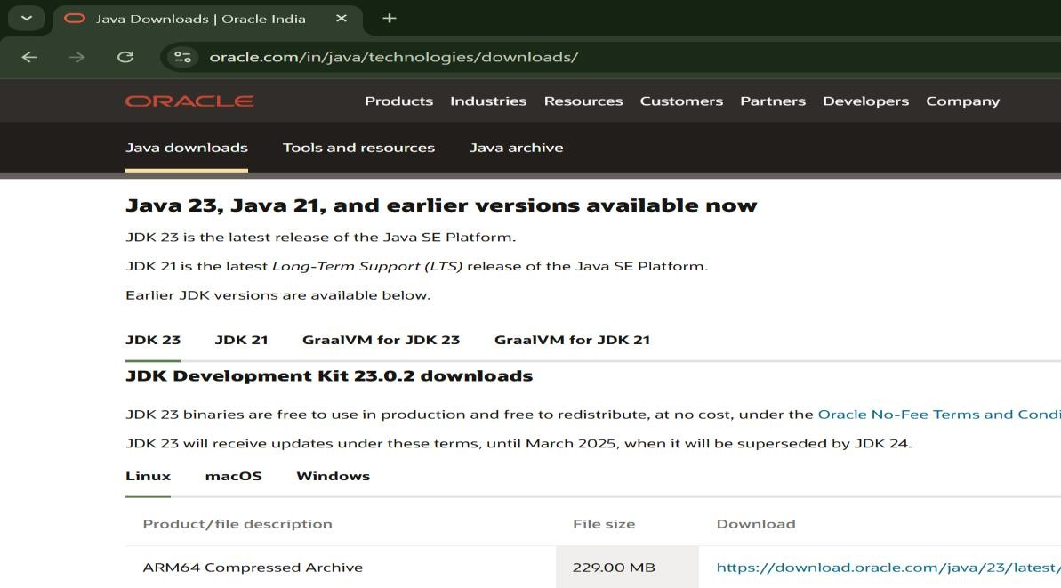

## Step-3:-click on JDK21 and click on windows and later click on x64 instalier link to download

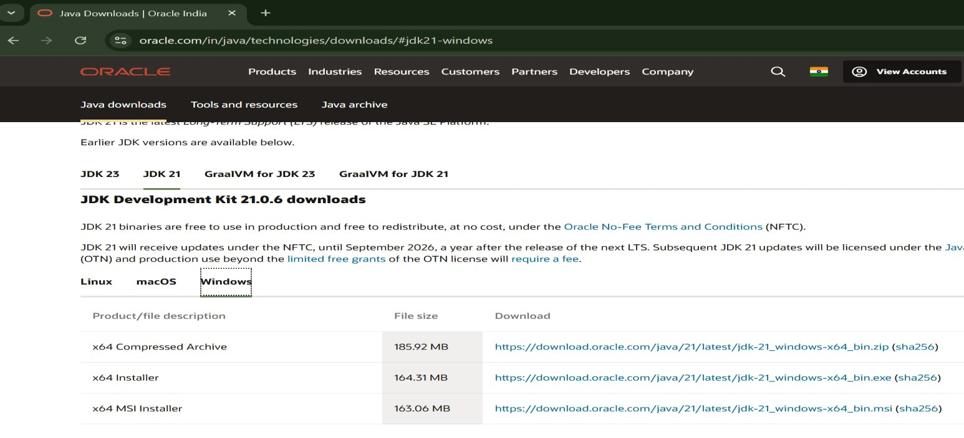

## Step-4:-After completing download click on it’s file and then give permission to install

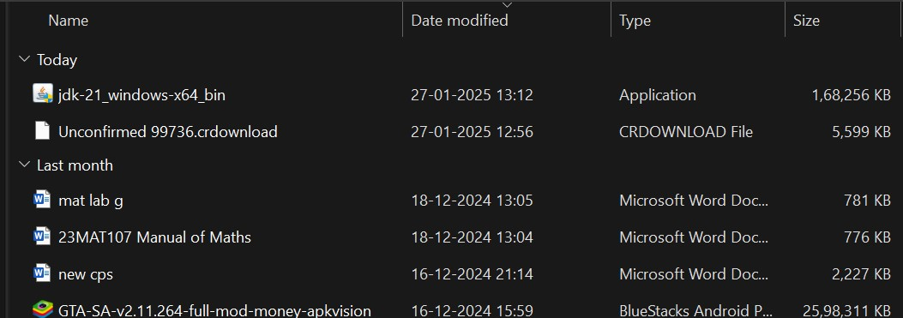

Step-5:-Then go to (This pc) in that click (windows{c}) in that click (Program files) in that click (Java) in that click (jdk-21) in that click (bin)

## Step-6:-Select and copy path of opening the file and then press windows and search System Environmental

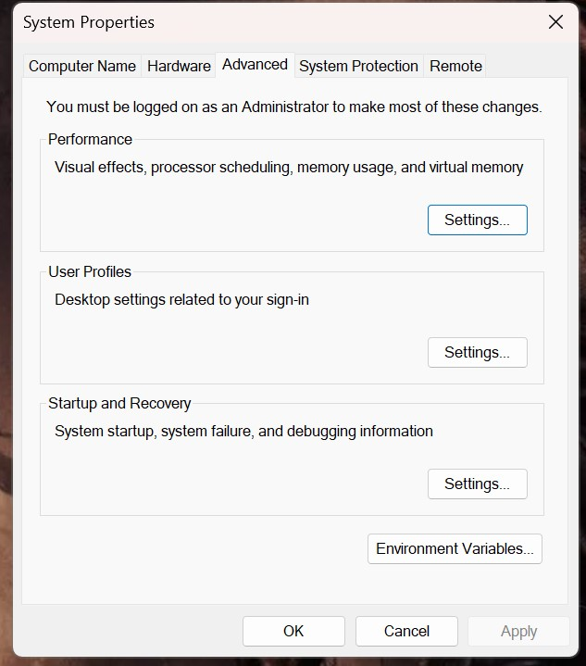

Step-7:-After opening Environment variables then past path of opening file in user variable and click on ok

## Step-8:-To verify version open CMD and type java --version

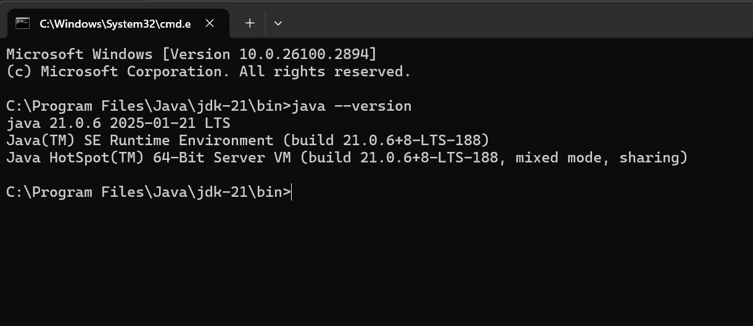

**Program : 2**

## Aim:-write a java program to print[welcome to java programming] Input:-

class ex_1{

public static void main(String[] args){

System.out.println("welcome to java programming");

}

}

## Output:-

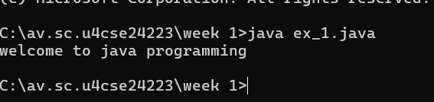

### Program : 3

Aim:-write a java program that prints name, roll no, section of the student Input:-

class Studentdet{

public static void main(String[] args){

System.out.println("Name= archith”);

System.out.println("section= cse-c");

System.out.println("rollno= 24223");

}

}

### Output:-

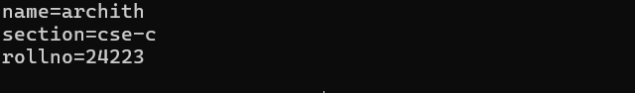

Week-2

Program:1

Aim: To write a java program on simple interest and by taking input from user

import java.util.Scanner;

public class SI {

    public static void main(String[] args) {

        Scanner scanner = new Scanner(System.in);

        System.out.println("Enter the principal amount: ");

        Float principal = scanner.nextFloat();

        System.out.println("Enter the interest rate: ");

        Float rate = scanner.nextFloat();

        System.out.println("Enter the time period: ");

        Float time = scanner.nextFloat();

        Float interest = (principal * rate * time) / 100;

        Float totalAmount = principal + interest;

        System.out.println("Simple Interest: " + interest);

        System.out.println("Total Amount: " + totalAmount);

    }

}

Output:

|  |  |  |  |
| --- | --- | --- | --- |
| S.No | Error | Reason of error | rectification |
| 1 | Syntax error | ; missing | ; added |
| 2 | Logical error | Wrong formula (principal*rate*time) | Corrected formula  by (principal*rate*time)/100 |

Program:2

Aim: To write a java program on factorial of a number by taking input from user

import java.util.Scanner;

public class Factorial {

public static void main(String[] args) {

Scanner scanner = new Scanner(System.in);

System.out.print("Enter a number to calculate its factorial: ");

int number = scanner.nextInt()

if (number < 0) {

System.out.println("Factorial is not defined for negative numbers.");

} else {

long factorial

for (int i = 1; i <= number; i++) {

factorial *= i;

}

System.out.println("The factorial of " + number + " is: " + factorial);

}

scanner.close();

}

}

Output: 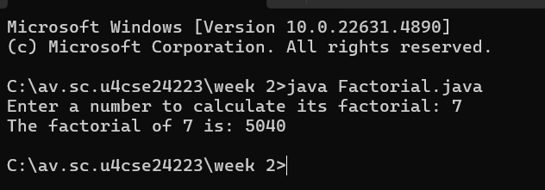

Error table:

|  |  |  |  |
| --- | --- | --- | --- |
| S.No | Error | Reason of error | Rectification |
| 1 | Syntax error | } error | Fixed with keeping } |
| 2 | Missing import statement | Didn’t importing packages | Packages imported |
| 3 | Run time | Incorrect path | Fixed with correct path |

Program:3

Aim: To write a java program to convert temperature from Fahrenheit to Celsius

import java.util.Scanner;

public class Temp {

public static void main(String[] args) {

Scanner scanner = new Scanner(System.in);

System.out.print("Enter temperature in Fahrenheit: ");

float fahrenheit = scanner.nextFloat();

float celsius;

celsius = (fahrenheit - 32) * 5 / 9;

System.out.println("The temperature in Celsius is: " + celsius);

scanner.close();

}

}

Error table:

|  |  |  |  |
| --- | --- | --- | --- |
| S.No | Error | Reason of error | Rectification |
| 1 | Logical error | Incorrect formula celsius = (fahren - 32) * 5/9; | Corrected by formula Celsius=(fahren-32)*5/9 |
| 2 | Missing import statement | Util package is missing | Util package is added |

Program:4

Aim: To write a java program to calculate the fibonacii sequence and take the input from user

import java.util.Scanner;

public class Fib {

public static void main(String[] args) {

Scanner scanner = new Scanner(System.in);

System.out.print("Enter the number: ");

int n = scanner.nextInt();

if (n <= 0) {

System.out.println("Please enter a positive integer.");

} else {

long f1 = 0, f2 = 1;

System.out.print(f1 + " ");

if (n > 1) {

System.out.print(f2 + " ");

}

for (int i = 3; i <= n; i++) {

long f3 = f1 + f2;

System.out.print(f3 + " ");

f1 = f2;

f2 = f3;

}

}

scanner.close();

}

}

Error table:

|  |  |  |  |
| --- | --- | --- | --- |
| S.No | Error | Reason of error | Rectification |
| 1 | Logical error | Incorrect formula | Fixed with correct formula |
| 2 | Run time | Incorrect path | Added correct path |

Program:5

Aim: To write a java program to find the area of triangle by using heron’s formula taking the input from the user

import java.util.Scanner;

public class Heron {

public static void main(String[] args) {

Scanner scanner = new Scanner(System.in);

System.out.print("Enter the length of side a: ");

double a = scanner.nextDouble();

System.out.print("Enter the length of side b: ");

double b = scanner.nextDouble();

System.out.print("Enter the length of side c: ");

double c = scanner.nextDouble();

double s = (a + b + c) / 2;

double area = Math.sqrt(s * (s - a) * (s - b) * (s - c));

if (a + b > c && b + c > a && c + a > b) {

System.out.println("The area of the triangle is: " + area);

} else {

System.out.println("it do not from triangle.");

}

scanner.close();

}

}

Error table:

|  |  |  |  |
| --- | --- | --- | --- |
| S.No | Error | Reason for error | Rectification |
| 1 | Logical error | Incorrect formula | Fixed with correct formula |
| 2 | Name error | Undeclared variable | Variable declared |

Program:6

Aim:To write java program to find the area of rectangle:

import java.util.Scanner;

public class Rectangle {

public static void main(String[] args) {

Scanner scanner = new Scanner(System.in)

System.out.print("Enter the length of the rectangle: ");

double length = scanner.nextDouble();

System.out.print("Enter the width of the rectangle: ");

double width = scanner.nextDouble();

double area = length * width;

System.out.println("The area of the rectangle is: " + area);

scanner.close();

}

}

Error table:

|  |  |  |  |
| --- | --- | --- | --- |
| S.No | error | Reason of error | Rectification |
| 1 | Syntax | ; missing | ; added |
| 2 | Logical error | Incorrect formula | Fixed with correct formula |

Week-3

Program:1

Aim: To create a java program with following instructions

1.create a class with name car

2.create a four attributes named car_brand,car_color,fuel_type,mileage

3. Create three methods named start(), stop(). Service()

4. Create three objects named car1,car2 and car3

import java.util.*;

class car{

public String Car_color;

public String Car_brand;

public String fuel_type;

public int mileage;

public void start() {

System.out.println("Car Started:");

System.out.println("Car color is :"+Car_color);

System.out.println("Car Brand is:"+Car_brand);

System.out.println("Car fuel type is:"+fuel_type);

System.out.println("Car mileage is:"+mileage);

}

public void service() {

System.out.println("Car Started:");

System.out.println("Car color is :"+Car_color);

System.out.println("Car Brand is:"+Car_brand);

System.out.println("Car fuel type is:"+fuel_type);

System.out.println("Car mileage is:"+mileage);

}

public void stop(){

System.out.println("Car Started:");

System.out.println("Car color is :"+Car_color);

System.out.println("Car Brand is:"+Car_brand);

System.out.println("Car fuel type is:"+fuel_type);

System.out.println("Car mileage is:"+mileage);

}

public static void main(String args[]){

car car1 = new car();

car1.Car_color = "white";

car1.Car_brand = "tata";

car1.fuel_type = "ev";

car1.mileage = 70;

car1.start();

car car2 = new car();

car2.Car_color = "red";

car2.Car_brand = "ferrari";

car2.fuel_type = "petrol";

car2.mileage = 200;

car2.stop();

car car3 = new car();

car3.Car_color = "black";

car3.Car_brand = "benz";

car3.fuel_type = "diesel";

car3.mileage = 150;

car3.service();

}

Output: 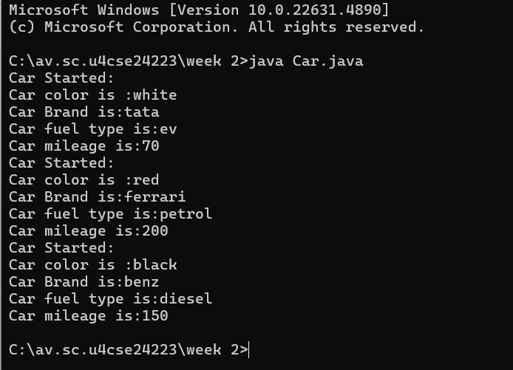

Error table:

|  |  |  |  |
| --- | --- | --- | --- |
| s.no | error | Reason of error | rectification |
| 1 | Syntax error | Type in the variable name mileage in the constructor | Corrected to mileage |

Class diagram:

|  |
| --- |
| Car |
| +carcolor: string  -carbrand:string  +mileage:int |
| +car():void  +start():void  +stop():void  +service:void |

Program:2

Aim:To create a class bank account with methods deposit() and withdrawl

public void withdraw(int amount) {

if (amount <= balance) {

balance -= amount;

System.out.println("Withdrawal of " + amount + " successful. Remaining balance: " + balance);

} else {

System.out.println("Insufficient balance for " + accname);

}

}

public void deposit(int amount) {

balance += amount;

System.out.println("Deposit of " + amount + " successful. Updated balance: " + balance);

}

public void displayDetails() {

System.out.println("Account Name: " + accname);

System.out.println("Account Number: " + acno);

System.out.println("Balance: " + balance);

}

public void blackbox(int withdrawAmount, int depositAmount) {

withdraw(withdrawAmount);

deposit(depositAmount);

displayDetails();

}

public static void main(String[] args) {

Bank_Account a = new Bank_Account("ARCHITH", 45678, 1324);

a.blackbox(3000, 200);

System.out.println();

Bank_Account a1 = new Bank_Account("ROHITH", 60000, 18000);

a1.blackbox(7000, 50000);

}

}

Errors:

|  |  |  |  |
| --- | --- | --- | --- |
| s.no | error | Reason of error | rectification |
| 1 | Missing balance dispaly | Withdraw and deposit methods update the | Add system.out.println on both methods |

Class diagram:

|  |
| --- |
| bank |
| -name:string  -accno:string  Currbal:string |
| +bankAccount():void  +deposit():int  +withdraw():void |

Week-4

Program:1

Aim: write a java program with class named “book”. the class shoukd contain various attributes such as title, author, year of publication. it should also contain a constructor with parameters which initializes title, author, year of publication and create a method which displays the details of 2 books.

class book{

    public String title;

    public String author;

    public int year_of_publication;

    public void start() {

        System.out.println("Title of the book is :"+title);

        System.out.println("Author  of the book is :"+author);

        System.out.println("Year of publication of the book is :"+year_of_publication);

    }

    public void service() {

        System.out.println("Title of the book is :"+title);

        System.out.println("Author of the book is :"+author);

        System.out.println("Year of publication of the book is :"+year_of_publication);

    }

    public static void main(String[] args){

        book book1=new book();

        book1.title="quantum theory";

        book1.author="Louis de Broglie";

        book1.year_of_publication=1924;

        book1.start();

        book book2=new book();

        book2.title="A Brief History of Time";

        book2.author="Stephen hawkimg";

        book2.year_of_publication=1988;

        book2.service();

        }

 }

Output:

Errors:

|  |  |  |  |
| --- | --- | --- | --- |
| s.no | error | Reason of error | rectification |
| 1 | Compilation error | Missing semicolon | Add semicolons at the end of the lines |
| 2 | Logical error | Missing spacing in the print statements | Add a space after year of publication in the display details () method |

Class diagram:

|  |
| --- |
| Book |
| - title: String  - author: String  - year: int |
| Book(String, String, int)  + displayDetails(): void |

Program:2

Aim: write a java program with class named “myclass” with a static variable count of int type. intialize it to zero and a constant variable “pi” of type double initialized to “3.14” as attributes of that class. now define a constructor for “myclass”, that increments the count variable each time an object of “myclass” is created. finally, print the final values of ‘count’ and ‘pi’ variables and create 3 objects

public class MyClass {

static int count = 0;

static final double pi = 3.14;

MyClass() {

count++;

}

public static void main(String[] args) {

MyClass obj1 = new MyClass();

MyClass obj2 = new MyClass();

MyClass obj3 = new MyClass();

System.out.println("Count: "+count);

System.out.println("Pi: "+pi);

}

}

Output:

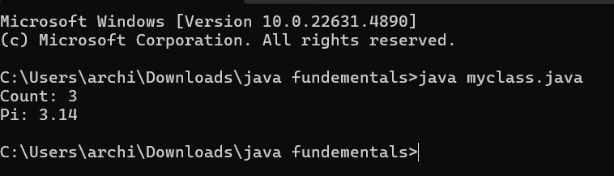

Errors:

|  |  |  |  |
| --- | --- | --- | --- |
| s.no | error | Reason of error | rectification |
| 1 | Logical error | Missing space in the println statement for count and pi | Add a space before +count and+pi in the println statement |

Class diagram:

|  |
| --- |
| MyClass |
| - count: int (static)  - pi: double (static final) |
| + MyClass()  + main(String[] args): void |